**Session report 11/04/2023:**

*LABAUVIE – RAFFAELLI EVA*

*ROB3*

After discussing with M.Masson, I modified the wheel design so it fits better the new way of using it :

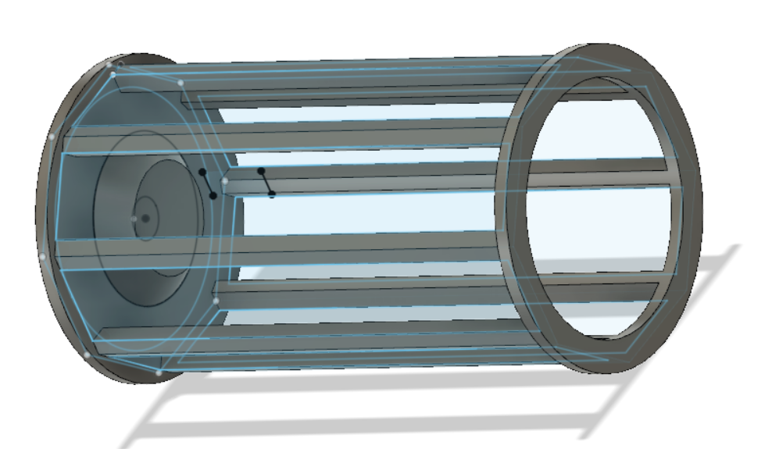

I cutted the axis in the middle because we won’t fix the step motor here, and made the edges rounded so the box that will be aroung can go aroung the wheel and it will still be able to spin smoothly.

Then I took back the Nvidia card to continue trying to get a working IA:









But it is unable to locate the package

I had an indecent number of errors or downloads that lasted days so I abandoned again this method and tried another one.

<https://learnopencv.com/deep-learning-based-object-detection-using-yolov3-with-opencv-python-c/>

<https://learnopencv.com/training-yolov3-deep-learning-based-custom-object-detector/>